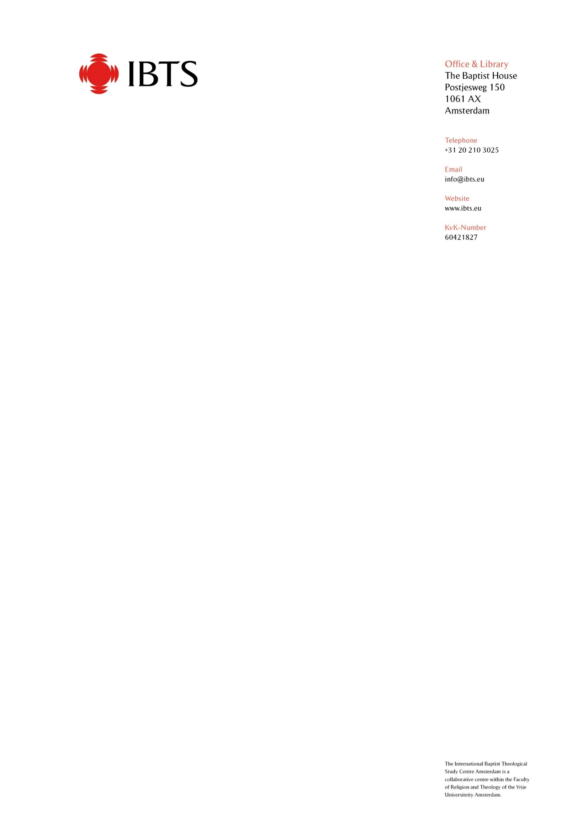

April 2022

Thank you for your interest in our PhD programme. Details about the programme, fees and charges are found on our website. Please ensure that you have read this.

Here you will find the application form and a form that you should send to referees. IBTS is open to receive applications through the early autumn and forms should be completed and received by IBTS as soon as possible.

Most of our students are part-time. The fees and charges stated in the Programme Information document do not include the cost of travel or accommodation when coming to and staying in Amsterdam. If you wish to study full-time, or require particular visa help, we may require more information than is requested here.

Once we have received your information, your application will be considered by the academic panel and you may be invited to take part in an interview with the Director and another member of the Centre’s academic team – normally by Zoom.

We will be able to advise you by when a decision will be made upon receipt of your application.

Mike Pears
Director of IBTS Centre

APPLICATION FOR ADMISSION PhD PROGRAMME IBTS

Please print clearly in block letters or type when filling-in the form. If questions do not pertain to your situation, please write “N/A” (not applicable) in the space provided.

- Personal Information
Surname: |  |  |  | First name:
Address:
Telephone: |  |  |  |  | Fax:
E-mail:
Date of birth: |  |  |  |  | Gender:
Place of Birth:
Present Citizenship: |  |  |  |  | Occupation:
Place of Employment: |  |  |  |  | For how long?

- Educational History
Have you previously applied to IBTS? Yes No
If yes, when?

- Have you done any THEOLOGICAL STUDIES at another institution?
Yes No
If yes, please provide the following information:
Name and Location of Institution  (No Abbreviations) | Degree/Date | Subject(s) | Years of Study  From - to

- Please list any other academic institution (post-secondary level) that you have attended.
Name and Location of Institution  (No Abbreviations) | Degree/Date | Subject(s) | Years of Study  From - to

Please request official transcripts from all post-secondary academic institutions where you have studied and have the transcripts or certificates sent to the Adminstrator at IBTS, The Baptist House, Postjesweg 150, 1061 AX, Amsterdam, The Netherlands. The academic transcripts must show the courses taken, the grade earned in each course, an explanation of the grading system, and the number of credit hours for each course, where this is the system followed. For purposes of initial application IBTS will accept digital copies but hard/certified copies will be required for registration at VU when applicable. At that stage we will also require a certified copy of final award. Please also send a copy of your valid passport with your application. Digital copies should be sent to administrator@ibts.eu.

- Languages Studied
Language | Name of institution where studied | How long ?
Greek
Hebrew

- List other languages you speak or have studied:
Language

- Financial Support
How do you plan to pay for your studies: Personal, Bursary, Church Support, Other?

- Please outline voluntary or paid engagement in Christian ministry.

- Research Proposal:
Part of the IBTS pre-registration programme is focused on helping students develop their research proposal. However, as part of the application process we want to ensure that you have given reasonable thought to your research topic and can demonstrate an awareness of the theological and methodological issues involved. Please provide the following outline information and restrict this section on research proposal to 1,000 words:

- What is your proposed topic of research?

- Please outline your reason for wishing to engage in this research

- What is the question you wish to answer through your research? State it as clearly and succinctly as possible.

- Methodology: How do you propose to go about answering the research question? What research methods will you use, how will you approach the question theologically?

- Where does your research fit in the context of current scholarship and what new contribution will it make to knowledge in the field?

- Who will be the main theological scholars with whom you will engage in your research, and why?

- Any other relevant information you wish to include in support of your application.

- Information on References
Please forward the Letter of Reference form to two individuals who can provide a reference for your academic performance. Please list below the two persons you have asked to complete the reference forms.

The forms should be sent directly by those persons to the Administrator at IBTS at the address given. They can be e-mailed to administrator@ibts.eu.

Name | Position/Title | Address

- Emergency Information
Person to notify in emergency:
Relationship to you:
Address:
Telephone: |  | Fax:

- Certification

I understand that I must take financial responsibility for my visa, tuition fee, health insurance accommodation and travel costs.
I certify that all the information provided with this application is true and voluntarily given, and I give my permission for this information to be used by the International Baptist Theological Study Centre Amsterdam for the purpose of considering admission, academic information and record keeping.

Signature: | Date:

Note: This application is not complete until WE HAVE received all the necessary information. No admission decision will be made without all the necessary information.

LETTER OF REFERENCE

Name of Applicant:

The above named person has made application for admission to doctoral studies at IBTS and has requested that you serve as a reference. When completing this form, please print clearly. Upon completion, please mail the form directly to: Administrator IBTSC, The Baptist House, Postjesweg 175, 1062 JN Amsterdam, The Netherlands, or e mail them to administrator@ibts.eu. We appreciate your willingness to evaluate this applicant. This reference is confidential and will not be seen by anyone other than the Admissions Committee although can be requested by the student.

How long and in what capacity have you known the applicant?

Please rate the applicant in comparison with others of similar age and position:

 | Superior | Excellent | Above Average | Average | Below Average | No basis for judgement
Ability in oral expression
Ability in written expression
Intellectual competence
Sense of purpose
Perseverance in achieving goals
Emotional maturity
Self-discipline and initiative
Imagination and probable creativity
Effectiveness in working with others
Social sensitivity
Past performance as a researcher
Potential as a researcher
Integrity/character

In the rest of the form the Centre would appreciate a statement from you concerning the applicant. Please evaluate the applicant’s reasons for undertaking research studies, ability for critical thinking and personal character. Honest statements are desired regarding the applicant’s strengths and limitations and their probable effect on success in vocation and academic pursuits.

Signature and Title: | Date:
Printed Name and Address:

- Please evaluate the Applicant’s reasons for undertaking research studies as well as his/her ability for critical thinking and coping with the academic requirements in general.

- Please assess the applicant’s strengths and limitations and their probable effect on success in his/her vocation and academic pursuits.

- Please evaluate the applicant’s personal character

- Please describe the applicant’s probable role after completion of his/her studies and if applicable your (or your organisation’s) commitment to this student.
Continue on further pages if necessary.

